Reference link:

<https://pioneercode.com/post/building-a-hyper-v-windows-10-vagrant-box>

Steps:

1. Copy metadata.json file to the folder where Base VM files exist.

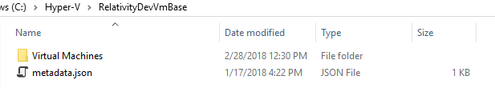

**Contents of metadata.json:**

{

"provider": "hyperv"

}

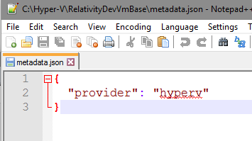

1. Select all the files in this folder, right-click and do ‘Add to archive’ 7-zip option

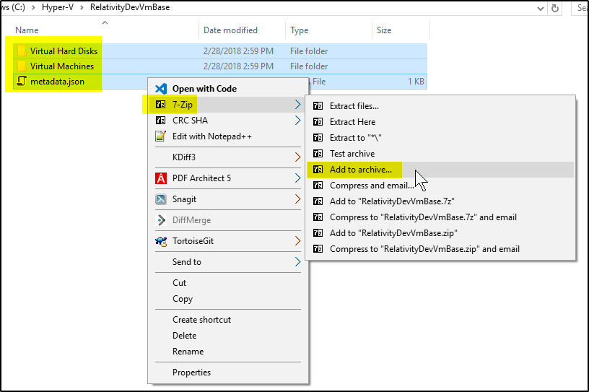

1. Tar zip the contents

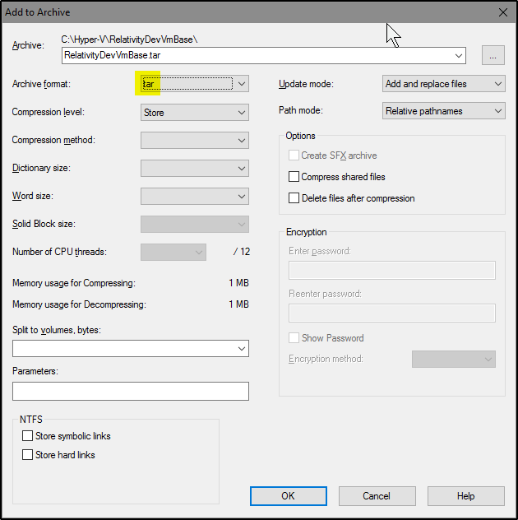

1. Gzip RelativityDevVmBase.tar

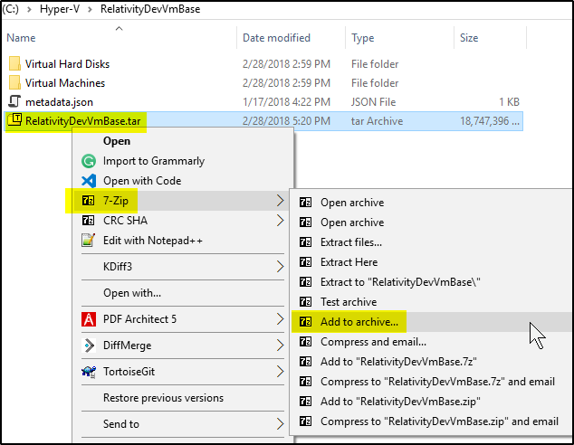

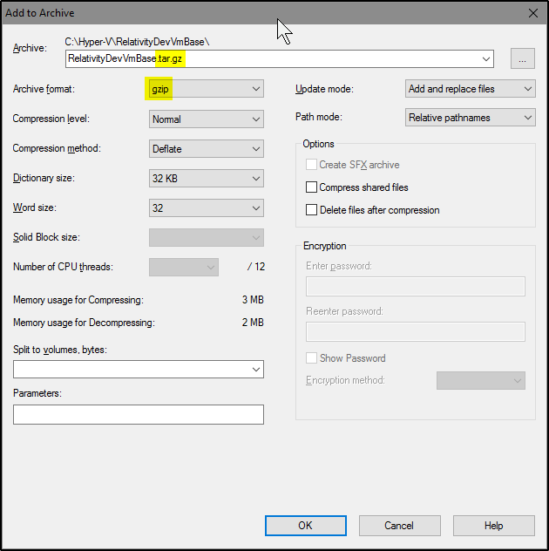

1. Rename .tar.gz extension to .box

